COMPREHENSIVE HOUSE PRICE ANALYSIS USING TABLEAU
Abstract
The comprehensive house price analysis project focuses on analyzing real estate data using tableau. The dataset consists of 21,609 records containing house sale prices and property-related attributes. The objective of this project is to visualize housing trends and extract meaningful insights through interactive dashboards. The system enables users to apply filters such as top 10 sale prices and age of house to understand price variations effectively. The dashboard was tested for performance and responsiveness and was successfully published on tableau public. The results demonstrate efficient data handling and smooth visualization performance.
Keywords:
House Price Analysis
Tableau
Data Visualization
Dashboard
Real Estate Analytics
1. Introduction
1.1 Project Overview
This project analyzes housing data using Tableau Public. The dataset contains 21,609 records including sale price and house age. Interactive visualizations were created to understand price trends and comparisons.
1.2 purpose
The purpose of this project is to simplify complex housing data into meaningful visual insights. It helps users compare prices and make informed real estate decisions.

2. Ideation Phase
2.1 Problem Statement
Real estate buyers and sellers face difficulty understanding price variations due to multiple influencing factors. A visual system is required to simplify large housing datasets.
2.2 Empathy Map
Users think about price value, feel confused about trends, compare properties, and need clear visual insights. Their pain point is handling large raw data, and their gain is easy comparison through dashboards.
2.3 Brainstorming
Different approaches were considered such as Excel charts and static reports. Tableau was selected due to its interactive and dynamic visualization capabilities.
3. Requirement Analysis
3.1 Customer Journey Map
User opens the dashboard → Applies filters → Observes trends → Compares houses → Makes decision
3.2 Functional Requirements
- Display sale price distribution
- Show house age analysis
- Apply filters
- Provide interactive charts
3.3 Non-Functional Requirements
- Fast loading
- User-friendly interface
- Efficient data handling

Data Flow Daigram
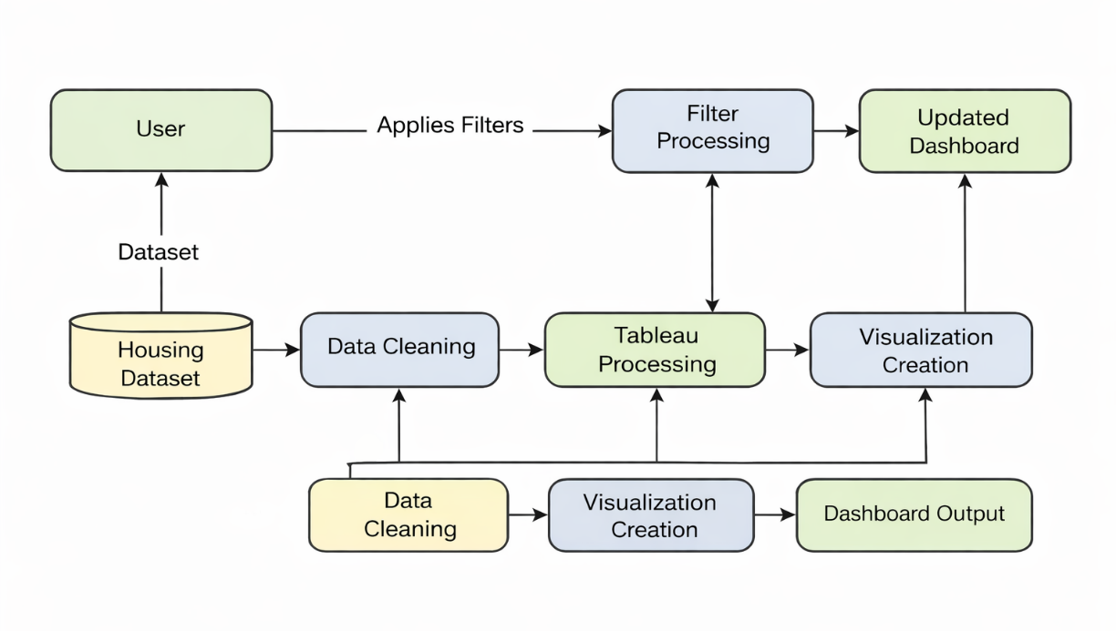
3.4 Technology Stack
Tool: Tableau Public
Dataset: House Price Dataset
Platform: Web-based Visualization
4. Project Design
4.1 Problem–Solution Fit
Problem: Complex housing data
Solution: Interactive Tableau dashboar
4.2 Proposed Solution
A dashboard that visualizes sale prices, age comparison, and Top 10 filters to provide meaningful insights.
4.3 Architecture
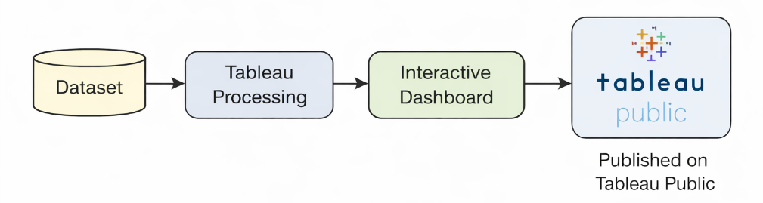

5. Project Planning And Scheduling
Steps followed:
- Data Collection
- Data Cleaning
- Dashboard Creation
- Testing
- Publishing
5.1 Project planning
Project planning is an essential phase that involves organizing tasks, allocating time, and defining milestones to complete the project successfully. In this project, a phase-wise development approach was followed.
Phase 1: Data Collection
The first step involved collecting the house price dataset containing 21,609 records. The dataset included various attributes such as sale price and house age. Understanding the structure and content of the dataset was crucial before proceeding to analysis.
Phase 2: Data Cleaning and Preparation
In this phase, the dataset was examined for inconsistencies, missing values, or formatting issues. Data cleaning ensured that the dataset was accurate and suitable for visualization in Tableau. Proper data preparation improved the reliability of the dashboard insights.
Phase 3: Dashboard Creation
After cleaning the data, multiple sheets were created in Tableau to analyze different aspects such as sale price distribution and house age comparison. These sheets were then combined into an interactive dashboard. Filters and layout adjustments were added to enhance usability.

Phase 4: Testing
Both functional and performance testing were conducted. Functional testing ensured that filters and visualizations worked correctly.
Performance testing confirmed that the dashboard loaded smoothly even with a large dataset of 21,609 records.
Phase 5: Publishing and Deployment
Finally, the dashboard was published on Tableau Public. The published link was then integrated into a web application using Flask and VS Code. This completed the deployment process.
6. Functional And Performance Testing
6.1 Functional Testing
All filters and visualizations were tested successfully. Chart interactions worked properly.
6.2 Performance Testing
The dataset contains 21,609 records. Top 10 filters were applied on sale price and age of house. The dashboard loaded smoothly without delay, confirming efficient performance.
7. Results
The dashboard successfully visualized housing trends and allowed interactive analysis. The visualization was successfully published on Tableau Public.

7.1Output Screenshots
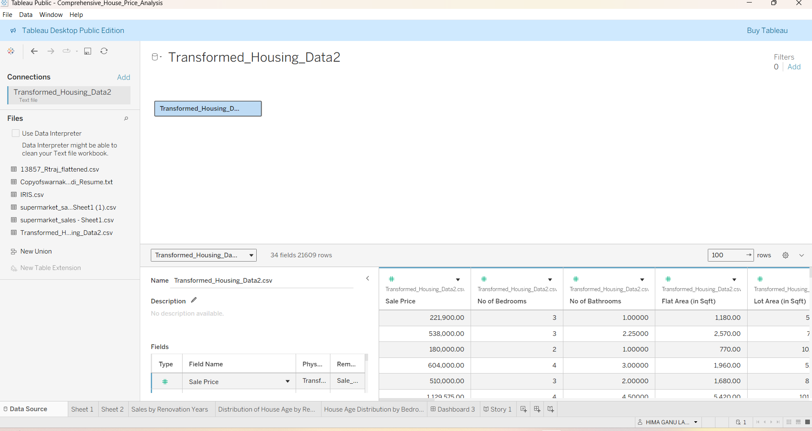
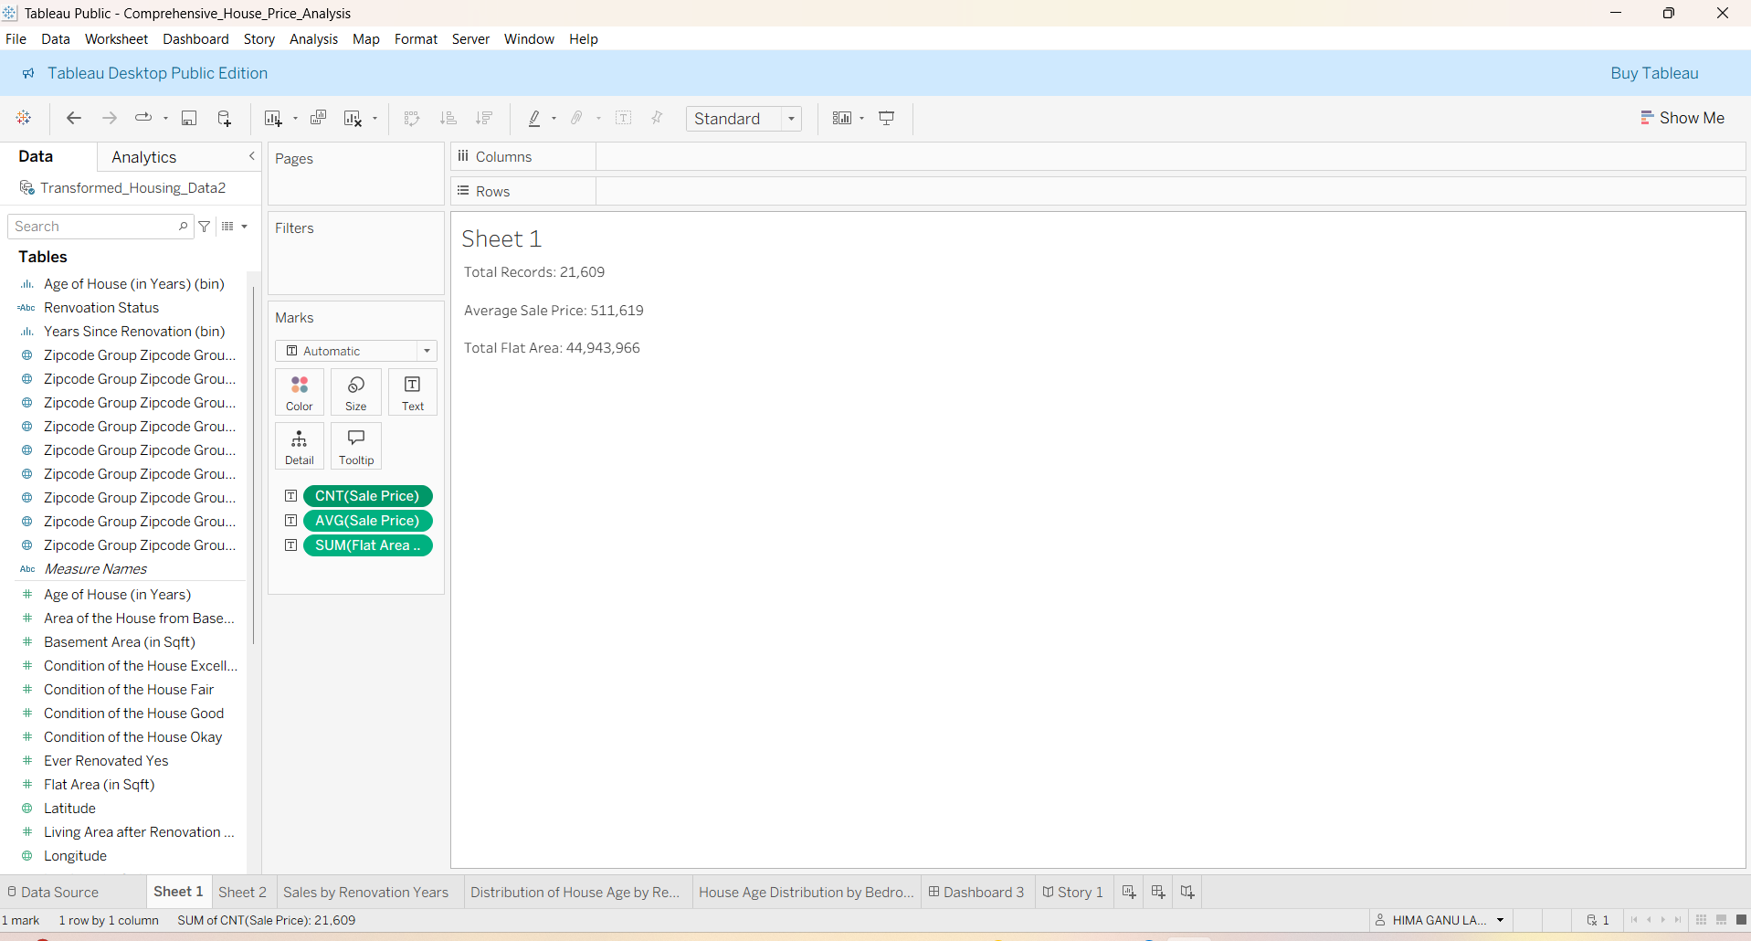
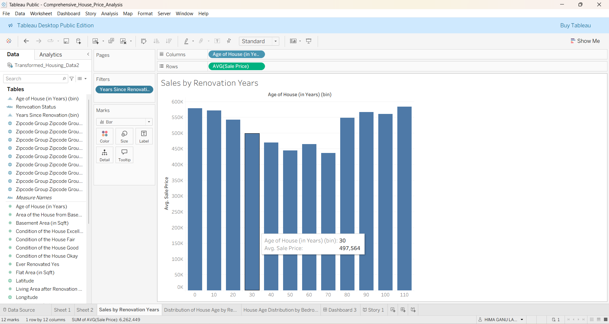
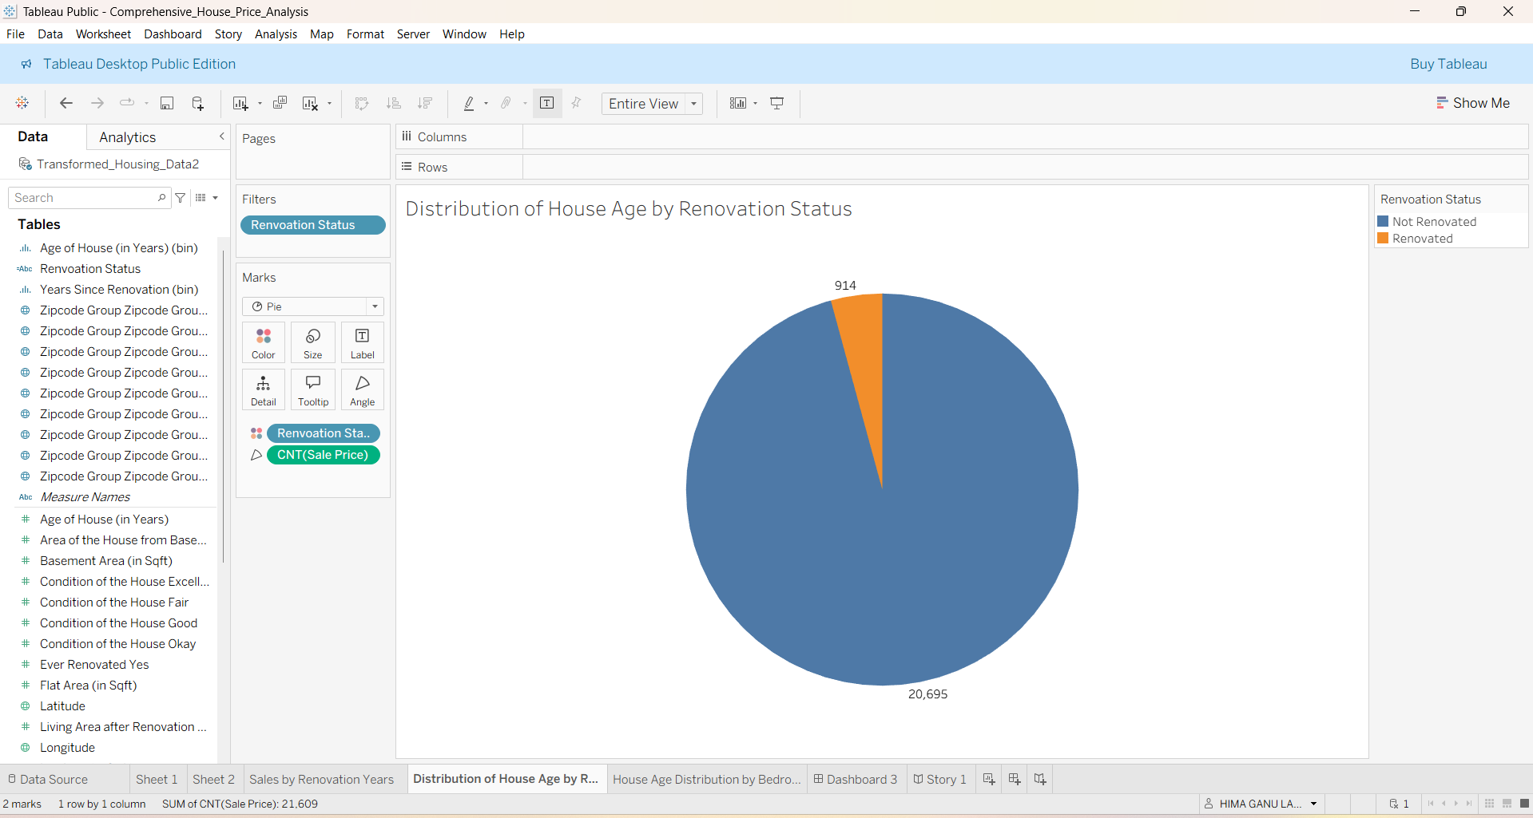
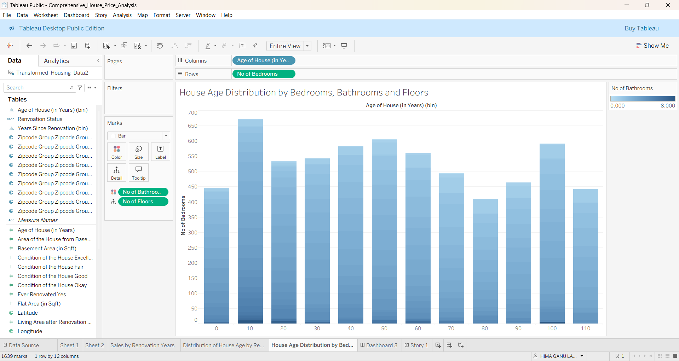
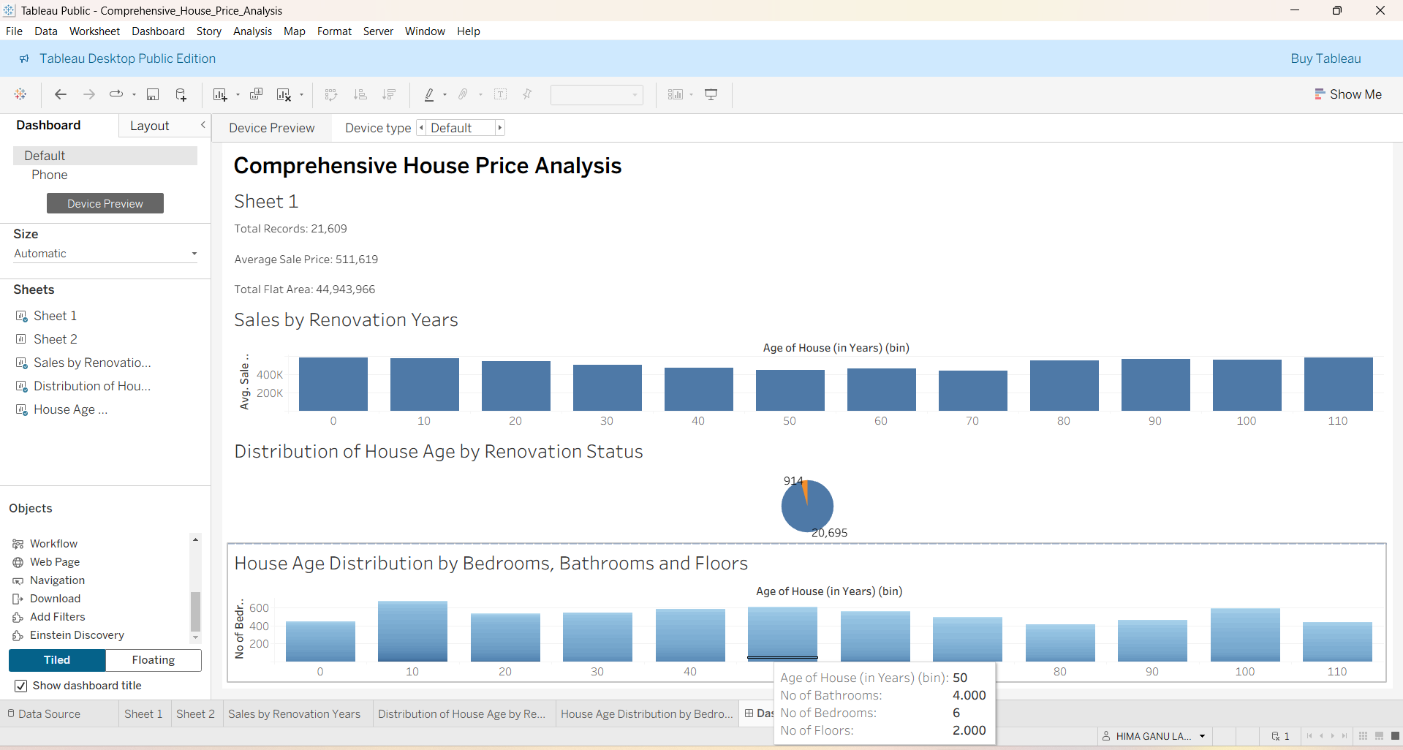
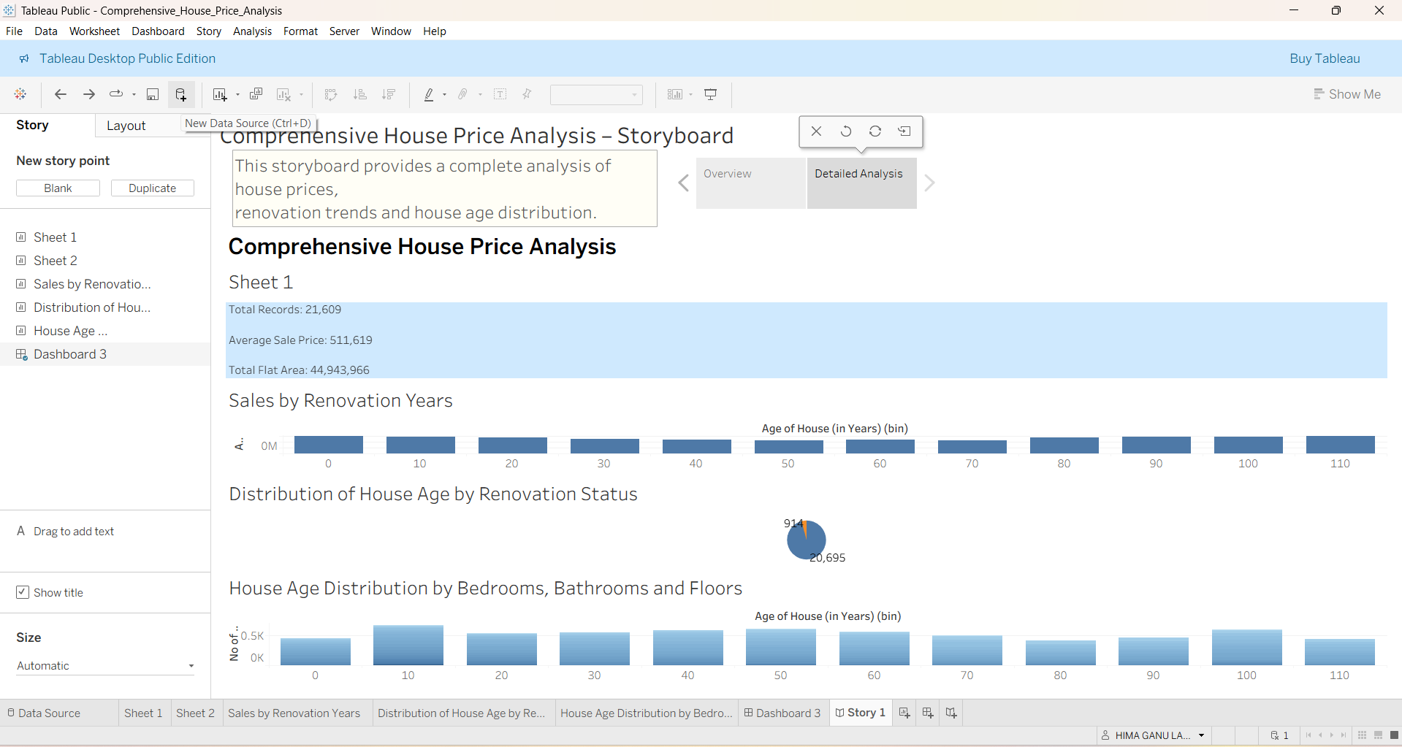
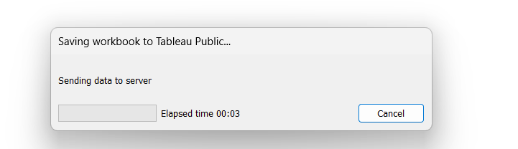
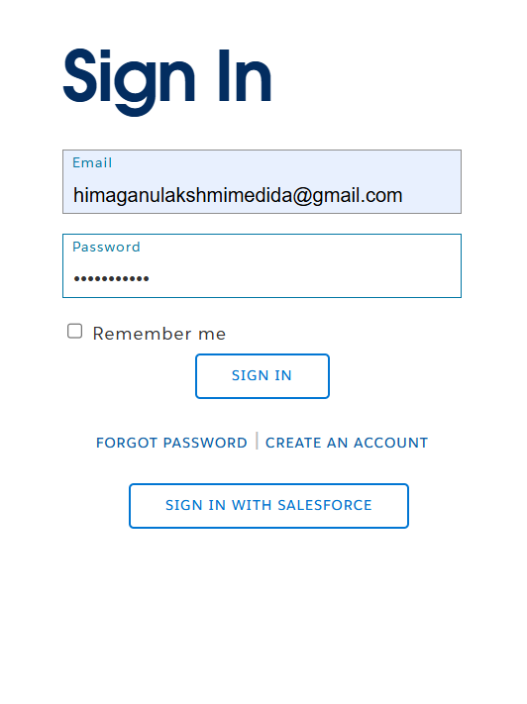
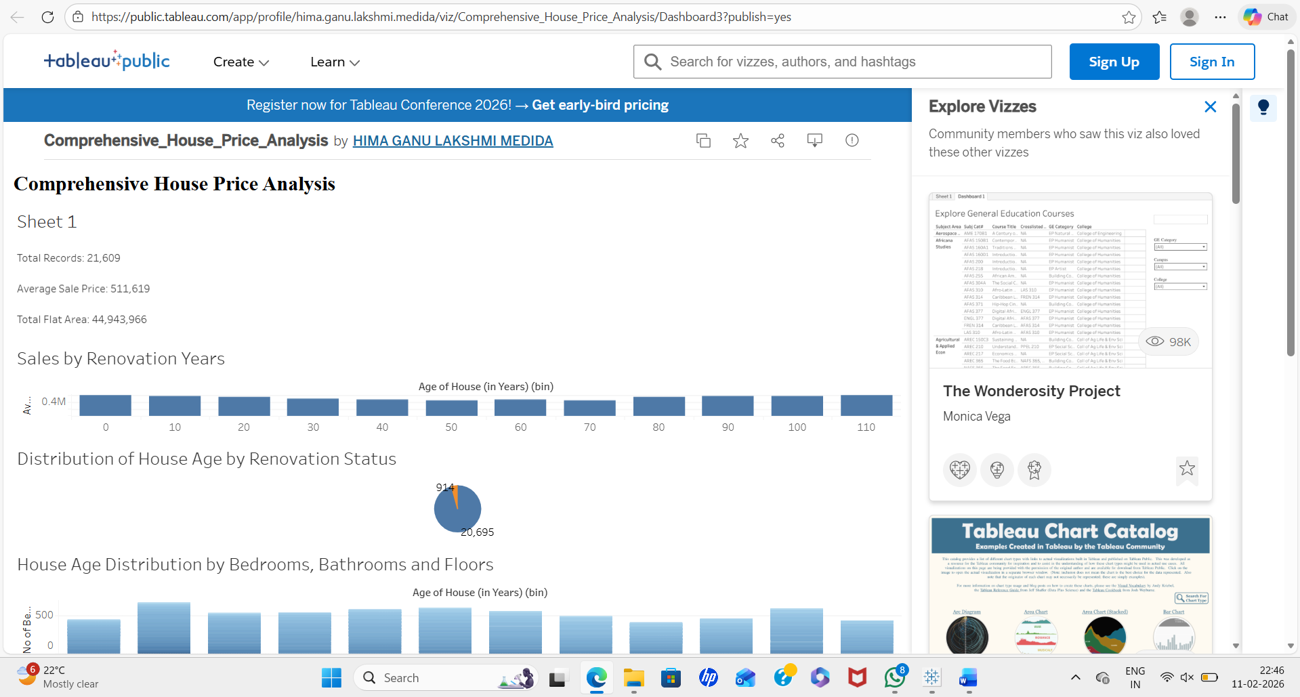
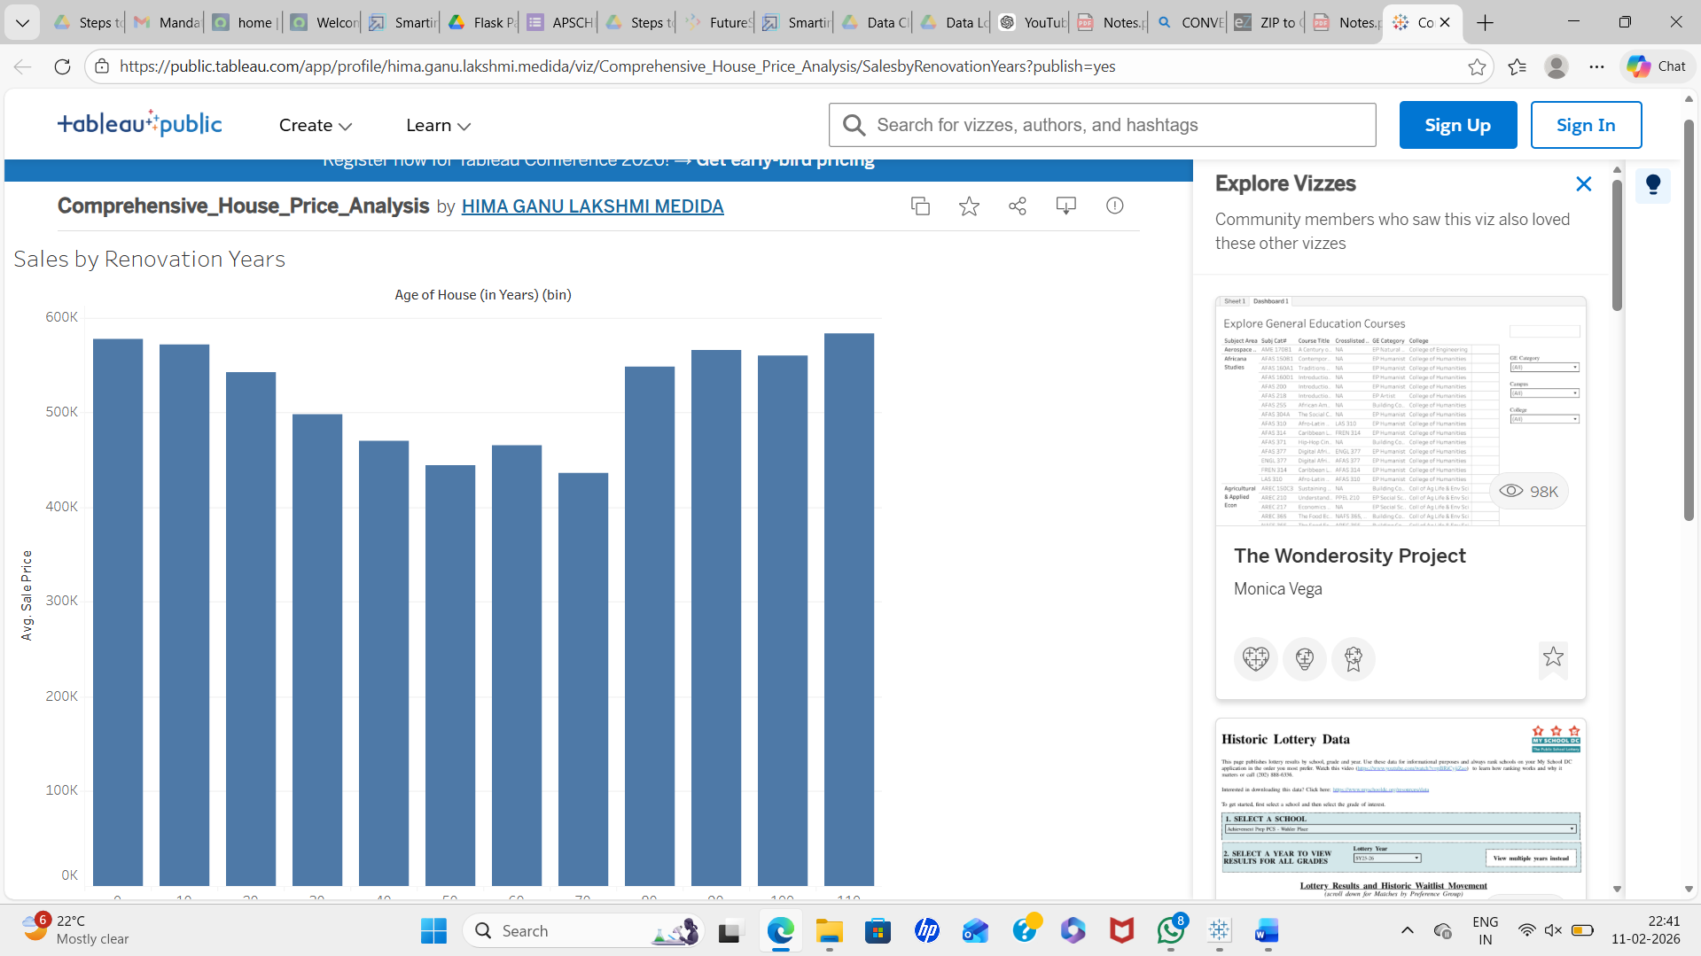
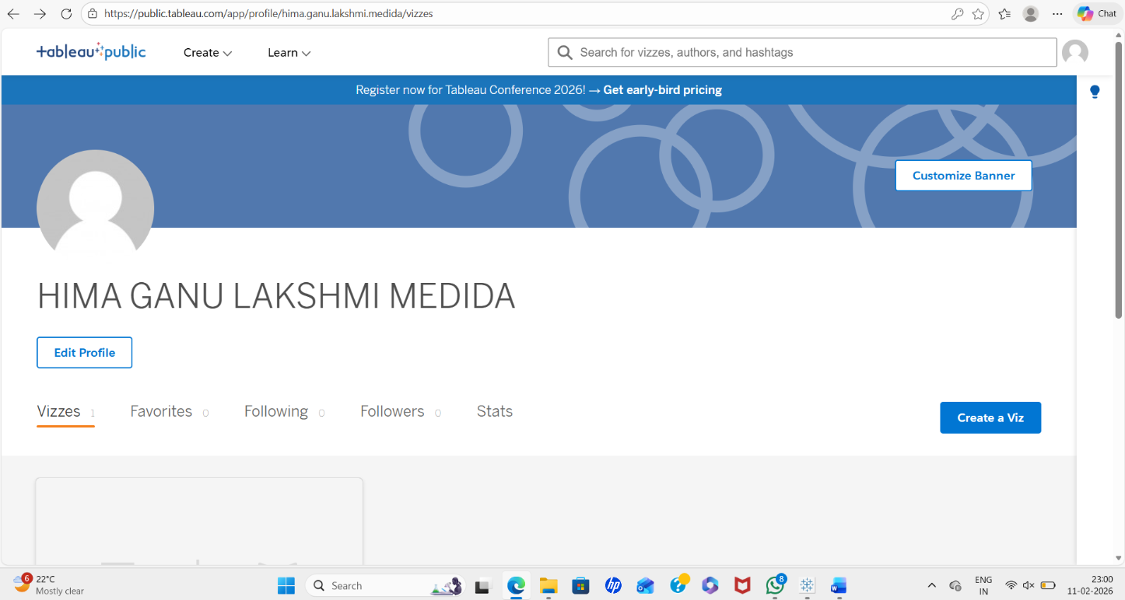
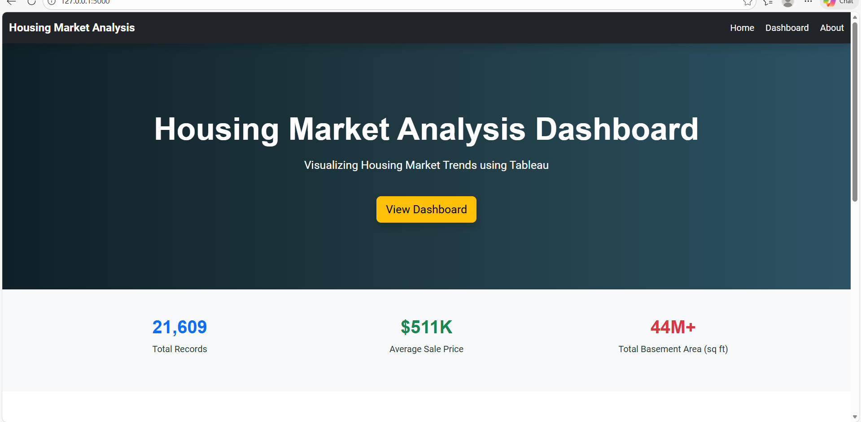
8. Advantages And Disadvantages
Advantages
- Interactive visualization
- Handles large dataset
- Easy comparison
- Web integration

Disadvantages
- Requires internet for Tableau Public
- Limited customization in free version
9. Conclusion
The project successfully analyzed housing data using Tableau. The dashboard provides meaningful insights into sale prices and house age trends. The system performs efficiently and is user-friendly.
10. Future Scope
- Add predictive analytics
- Integrate machine learning models
- Add more location-based filters
- Improve advanced analytics
11. Appendix
- Tableau Workbook: Comprehensive_House_Price_Analysis | Tableau Public
- DatasetLink:https://www.kaggle.com/datasets/rituparnaghosh18/transformed-housing-data-2
- Tableau Public Link: Profile - hima.ganu.lakshmi.medida | Tableau Public
- DemoVideoLink:https://drive.google.com/file/d/1y2-f4qaddHF2L8PSm-0bsKFKU8LRgKqE/view?usp=sharing
- Github Link: himaganulakshmimedida-blip/Visualizing-Housing-Market-Trends

